NCCRA Mountain Region 2019 Symposium

Location: Auditorium of Watauga Medical Center

336 Deerfield Road, Boone NC 28607

Date: Tuesday, November 5, 2019

Time: 8:30am to 2:00pm

Facilitator: Beth Ann Scott, MS, CES

Mountain Region Vice President

Agenda Items
8:30 – 8:55 Registration, Vendor Booths and
Breakfast – Provided by Pritikin
8:55 Welcome
Beth Ann Scott, MS, CES – NCCRA Mountain Region VP
9:00 – 10:00 Prehab for High-risk CV Surgical Patients
Hannah Wofford, EP and Sara Weaver, RN
10:00 – 11:00 Intensive Cardiac Rehab
Colleen Daubert, EP
11:00 – 12:00 Cardiology
Donna Denier, MD
12:00 – 12:30 Lunch – Provided by ScottCare

12:30 – 1:30 Opportunities in Testing & Training Patients with Cardiovascular Disease Jeff Soukup, PhD

1:45 – 2:00 Closing Remarks and Certificates
Beth Ann Scott

Additional Information
An application has been made to the American Association of Cardiovascular and Pulmonary Rehabilitation (AACVPR) for 4 CE credits.
Special Thanks to Pritikin for breakfast and to Scott Care for lunch today. Please take some time to visit with them.
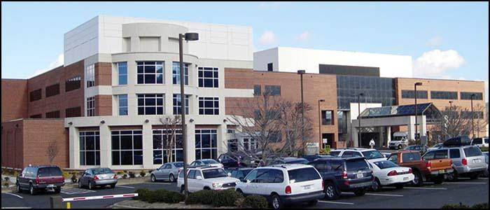
The auditorium of Watauga Medical Center is located in the white/glass-window looking area on the left of the hospital, on the 1st floor.

