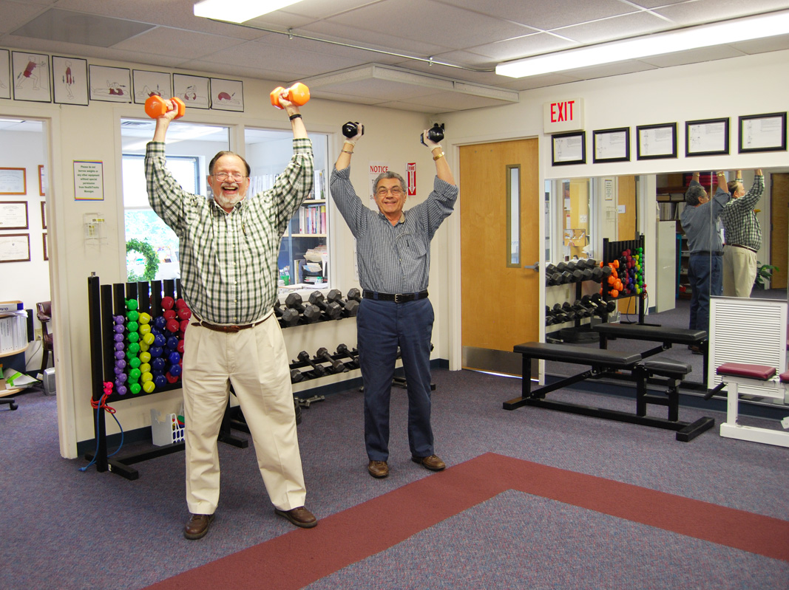
Highlands-Cashiers Hospital’s Cardiac Rehabilitation Program through HealthTracks graduated two patients this past month. Both of whom, with overwhelming stories of survival, completed the nationally certified eight week rehab program heart healthy and strong.
After a routine stress test performed at Highlands-Cashiers Hospital, (Pictured on the Left) Highlands resident Duncan Parham found himself on the operating table undergoing triple bi-pass surgery. An otherwise healthy active person, Parham had no associated pain and was just as surprised as the doctor when he was told of the 100% arterial blockage. Soon after the test findings, catheterization and cardiac surgery at Mission Health under the care of Asheville Cardiology’s Dr. Oliver Binns and Dr. Laura Verde , he is now back on his feet with the completion of Cardiac Rehab. “Like many of our cardiac rehab patients, Mr. Parham came to us in early June feeling very anxious, apprehensive and in a deconditioned state of health,” said Yvonne Smith, Registered Dietitian and HealthTracks Program Director. “But, a primary difference was his motivation and dedication to regain – or even surpass – his former state of health! He stayed very focused on getting stronger, getting healthier and getting off oxygen while exercising. He assumed responsibility for his health, and that made all the difference. His progress in less than three months has been excellent. As he ends his program, I feel certain he will continue on a path of improved health, strength and quality of life.”
Jerry Calabretta’s (Pictured on the right) story is somewhat different; what some would call a miracle. A seasonal resident of nearly 15 years, Calabretta shares his time between Sapphire and Juno Beach FL. After almost a decade of various cardiac events and treatments including a heart attack at age 43, triple bi-pass surgery and placement of a defibrillator, his heart was worn and tired. An aggressive advocate for his own health, he persuaded his medial team for a more permanent prognosis and in early 2012 his name was placed on the heart transplant list at the Duke University’s Medical Center. Nearly five months in waiting, Calabretta received a new heart. Three days after transplant surgery, he was walking. With will power, faith and his supportive caregiver, as of today he is healthy and has completely two eight week sessions of Cardic Rebab.
“Jerry arrived at our Cardiac Rehab in January of this year after having had a heart transplant in November 2012, incidentally, this was the first heart transplant patient we had ever admitted to the HealthTracks Cardiac Rehab program since its inception,” said Smith. “Jerry’s determination and motivation to be fully well was to be admired. He has dedicated himself to improving his physical endurance and strength and has been very successful in exceeding the goals we normally set for our patients and clients. It has been an excellent journey for both he and our cardiac rehab staff as he travelled through our program. And, he has certainly been an inspiration to our other patients in cardiac rehab.”
HCH’s nationally certified Cardiac Rehabilitation program provides continuous cardiac monitoring of patients during exercise sessions, which include a combination of cardiovascular and strength training. The program also provides education in heart healthy nutrition, stress management, evaluation by a mental health specialist, and education in all areas of the function of the heart. In addition to improving cardiovascular health and strength, the program prepares its patients to carry on lifestyle changes and practices learned in the 12-week/36 session program. The Cardiac Rehab Program is directed by Smith, a Registered Dietician, and her staff of cardiac nurses and exercise specialists. The team works in close conjunction with board certified physicians, counselors, physical therapists and other medical professionals to make sure all programs are safe, as well as effective. Their goal is to provide the community with the tools needed to maintain a healthy and active lifestyle.
For more information on the Cardiac Rehabilitation program at HealthTracks, please call 526-1469.

